Goals:
- I can write equations of parabolas in standard form.
- I can graph parabolas.
Equations of Parabolas
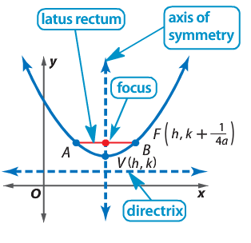
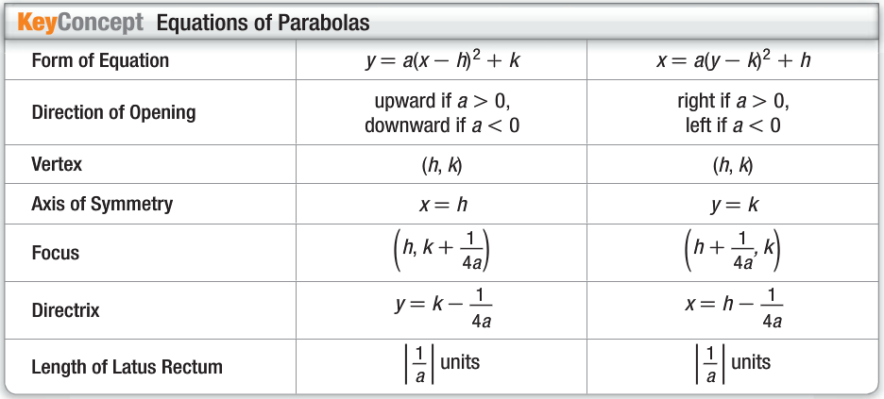

Standard form: $y=a{\left(x-h\right)}^{2}+k$
General form: $y=ax^{2}+bx+c$

Example 1: Analyze the Equation of a Parabola
Write $y=2x^{2}-12x+6$ in standard form. Identify the vertex, axis of symmetry, and direction of opening of the parabola.
$$y=$$ | $$2x^{2}-12x+6$$ | Original Equation
 | $$2\left(x^{2}-6x\right)+6$$ | Factor 2 from the x- and $x^{2}$- terms.
 | $2(x^{2}-6x+$ $)+6-2($ $)$ | Complete the square on the right side.
 | $$2\left(x^{2}-6x+ ____\right)+6-2\left(____\right)$$ | The 9 added when you complete the square is multiplied by 2.
 | $$2{\left(x-3\right)}^{2}-12$$ | Factor.
*The number that goes in the box comes ${\left(-\frac{6}{2}\right)}^{2}$. The $-6$ came from the number next to the x in step 2. Always divide by 2 and always square the number.*
a= _________
h= _________
k= _________

The vertex is (_____, _____)
The equation of the axis of symmetry is __________.
The parabola opens ________________.

Formula: | This Example
Focus: $\left(h, k+\frac{1}{4a}\right)$
Directrix: $y=k-\frac{1}{4a}$
Length of Latus Rectum: $\left|\frac{1}{a}\right|$ units

Example 2: Find all pieces of the equation and graph the equation.
$$y+2x^{2}+32=-16x-1$$
Use completing the square to put the equation into STANDARD FORM.

a= _________
h= _________
k= _________

The vertex is (_____, _____)
The equation of the axis of symmetry is __________.
The parabola opens ________________.

Formula: | This Example
Focus: $\left(h, k+\frac{1}{4a}\right)$

Directrix: $y=k-\frac{1}{4a}$
Length of Latus Rectum: $\left|\frac{1}{a}\right|$ units

