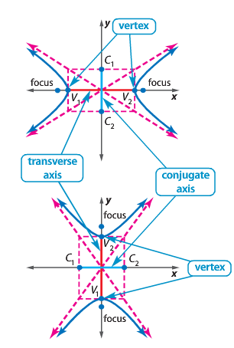
Goals:
- I can write equations of hyperbolas.
- I can graph hyperbolas.
HW: Finish WS

Equations of Hyperbolas—every hyperbola has two axes of symmetry, the transverse axis and the conjugate axis. They two axes are perpendicular at the center of the hyperbola.

Ellipses | Both | Hyperbolas
-No asymptotes  -Find c value:  $$c^{2}=a^{2}-b^{2}$$  -Length of Major/Minor | -Center is the same  -FIND length the same way | -2 asymptotes  -Finding c value: $c^{2}=a^{2}+b^{2}$  -Length of Transverse/Conjugate

