Goals:
- I can write the equation of an ellipse.
HW: Complete problems on the back

Example 1: Write an Equation Given the Vertices and Co-Vertices
Write an equation for the ellipse with vertices at $(6, -8)$ and $(6, 4)$ and the co-vertices at $(3, -2)$ and $(9, -2)$.
Look at the vertices and what do you see? | The x’s don’t change, so the ellipse is  _____________________________________
Find the center of the ellipse using midpoint formula: $\left(\frac{x_{1}+x_{2}}{2},\frac{y_{1}+y_{2}}{2}\right)$ | Center: _______________________________
The length of the major axis the distance between the two vertices. | Major axis length: ______________________
The length of the minor axis is the distance between the two co-vertices. | Minor axis length: ______________________
The equation for the ellipse:
$$\frac{{\left(y-k\right)}^{2}}{a^{2}}+\frac{{\left(x-h\right)}^{2}}{b^{2}}=1$$
Finding foci:
$$c^{2}=a^{2}-b^{2}$$
$a$ is the distance from center to a co-vertex
$b$ is the distance from the center to a vertex

This value is then added and subtracted to the center, but in the same direction as the vertices. This means the vertices, center, and foci are all in line with each other

Example 2: Write an Equation Given the Vertices and Co-Vertices
Vertices: $(-2, -6)$ and $(-2, 4)$
Co-Vertices: $\left(-5, -1\right)$ and $\left(1, -1\right)$
Look at the vertices and what do you see?
The x’s don’t change, so the ellipse is . . .
Find the center of the ellipse using midpoint formula:  $\left(\frac{x_{1}+x_{2}}{2},\frac{y_{1}+y_{2}}{2}\right)$ | Center: _______________________________
The length of the major axis the distance between the two vertices. | Major axis length: ______________________
The length of the minor axis is the distance between the two co-vertices. | Minor axis length: ______________________
The equation for the ellipse:
$$\frac{{\left(y-k\right)}^{2}}{a^{2}}+\frac{{\left(x-h\right)}^{2}}{b^{2}}=1$$
Finding foci:
$$c^{2}=a^{2}-b^{2}$$
$a$ is the distance from center to a co-vertex
$b$ is the distance from the center to a vertex

This value is then added and subtracted to the center, but in the same direction as the vertices. This means the vertices, center, and foci are all in line with each other
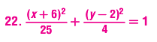
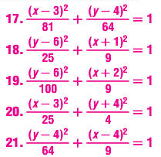
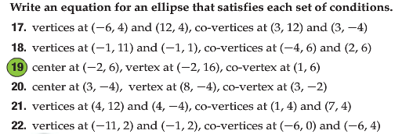
Answers are to the right

