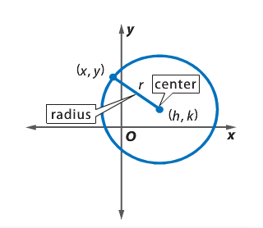
Goals:
- I can write equations of circles.
- I can graph circles.

Vocabulary and Formulas
Circle: the set of all points in a plane that are equidistant from a
given point in the plane
Center (h, k): the point that is equidistant from all points around a circle
Radius: any segment with endpoints at the center and a point on the
circle is a radius of the circle.
Midpoint: $\left(\frac{x_{1}+x_{2}}{2},\frac{y_{1}+y_{2}}{2}\right)$
Distance: $d=\sqrt{{\left(x_{1}-x_{2}\right)}^{2}+{\left(y_{1}-y_{2}\right)}^{2}}$
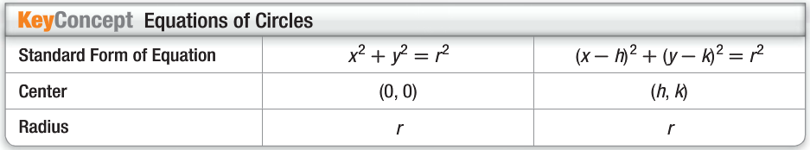

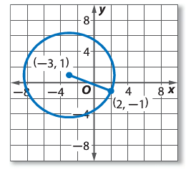
Example 1: Write an Equation from a Graph
Steps | Explanation
$${\left(x-h\right)}^{2}+{\left(y-k\right)}^{2}=r^{2}$$ | Standard form of the circle.
 | Plug in what you know.
 | Simplify inside the parentheses
 | Use distance formula to find the radius
 | Simplify for $r^{2}$
 | Write the final equation of the circle!

Example 2: Write an equation for a circle if the endpoints of a diameter are at $(7, 6)$ and $(-1, -8)$.
Step 1: Find the center.  $$\left(h, k\right)=\left(\frac{x_{1}+x_{2}}{2},\frac{y_{1}+y_{2}}{2}\right)$$ | Midpoint Formula using the two points given.
Step 2: Find the radius.  $$r=\sqrt{{\left(x_{1}-x_{2}\right)}^{2}+\left(y_{1}-y_{2}\right)}$$ | Distance formula using one of the points given and the center.  Since $r=\sqrt{260}$  then $r^{2}=260$.
Step 3: Put it all together!  $${\left(x-h\right)}^{2}+{\left(y-k\right)}^{2}=r^{2}$$ | Substitute h, k, and $r^{2}$ into the standard form of the equation of a circle.

Example 3: Write an equation for each circle given the center and radius.
Center: $(4, 9)$, $r=6$

Original Equation: ${\left(x-h\right)}^{2}+{\left(y-k\right)}^{2}=r^{2}$

Substitute in what you have:

Example 4: Graph an Equation in Standard Form
Find the center and radius of the circle with equation ${(x-1)}^{2}+{(y+2)}^{2}=100$. Then graph the circle.
Questions to ask yourself?
What is the center of the circle?

What is the radius?

What are some other points on the circle?
x | y
0
6
8
10

